**[ 2 ] MVT 익히기 프로젝트**

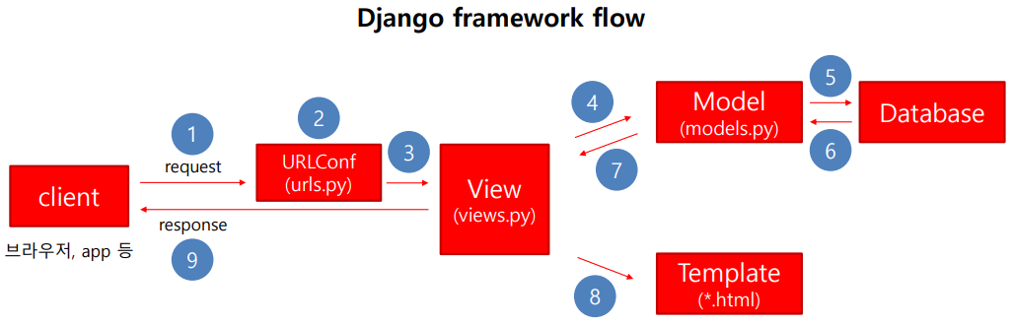

1. 모든 페이지 구현 순서
   1. 프로젝트 생성 및 애플리케이션 생성 등록
2. Ch02/settins.py

INSTALLED_APPS = [  
 **'django.contrib.admin'**,  
 **'django.contrib.auth'**,  
 **'django.contrib.contenttypes'**,  
 **'django.contrib.sessions'**,  
 **'django.contrib.messages'**,  
 **'django.contrib.staticfiles'**,  
 **'home.apps.HomeConfig'**,  
 **'wordcnt'**,  
]

생략

TEMPLATES = [  
 {  
 **'BACKEND'**: **'django.template.backends.django.DjangoTemplates'**,  
 **'DIRS'**: [**'wordcnt/tempates'**],  
 **'APP_DIRS'**: **True**,  
 **'OPTIONS'**: {  
 **'context_processors'**: [  
 **'django.template.context_processors.debug'**,  
 **'django.template.context_processors.request'**,  
 **'django.contrib.auth.context_processors.auth'**,  
 **'django.contrib.messages.context_processors.messages'**,  
 ],  
 },  
 },  
]

생략

STATIC_URL = **'/static/'***# STATICFILES_DIRS = [  
# BASE_DIR / "static",  
# '/css/static/',  
# ]*

* 1. URLconf
     1. ch02/urls.py

**from** django.contrib **import** admin  
**from** django.urls **import** path, include, re_path  
**from** django.conf.urls **import** url  
**from** home **import** views  
  
urlpatterns = [  
 path(**'admin/'**, admin.site.urls),  
 url(**r'^$'**, views.index, name=**'index'**),  
 path(**'test/'**, views.test, name=**'test'**),  
 *#re_path(r'test/(?P<id>[1-9]+)/$', views.intId, name="testIntId"),* path(**'showId/<int:id>/'**, views.intId, name=**"showIntId"**),  
 path(**'showId/<str:id>/'**,views.strId, name=**"showStrId"**),  
 url(**'wordcnt/'**, include(**'wordcnt.urls'**))  
]

* + 1. wordcnt/urls.py

**from** django.urls **import** path  
**import** wordcnt.views  
  
app_name = **'wordcnt'**urlpatterns = [  
 path(**''**, wordcnt.views.wordinput, name=**"wordinput"**),  
 path(**'about/'**, wordcnt.views.about, name=**'about'**),  
 path(**'result/'**, wordcnt.views.result, name=**'result'**),  
]

* 1. Views
     1. home/views.py

**from** django.shortcuts **import** render  
**from** django.http **import** HttpResponse  
  
**def** index(request):  
 msg = **'My message는 Hello, Django!'  
 return** render(request, **'home/index.html'**, {**'msg'**:msg})  
  
**def** test(request):  
 **return** HttpResponse(**'<h1>테스트</h1><h2>페이지</h2>'**)  
  
**def** intId(request, id):  
 msg = **"숫자 ID는 "**+str(id)  
 type = **"숫자"  
 return** render(request, **'home/test.html'**, {**'msg'**:msg, **'type'**:type})  
  
**def** strId(request, id):  
 msg = **"문자 ID는 "** +id  
 type = **"문자"  
 return** render(request, **'home/test.html'**, {**'msg'**:msg, **'type'**:type})

1. wordcnt/views.py

**from** django.shortcuts **import** render  
  
**def** wordinput(request):  
 **return** render(request, **'wordinput.html'**)  
  
**def** about(request):  
 **return** render(request, **'about.html'**)  
  
**def** result(request):  
 full = request.GET[**'fulltext'**]  
 strlength = len(full)  
 words = full.split()  
 words_dic = {}  
 **for** word **in** words:  
 **if** word **in** words_dic:  
 words_dic[word] += 1  
 **else**:  
 words_dic[word] = 1  
 **return** render(request, **'result.html'**, {**'full'**:full, **'strlength'**:strlength, **'cnt'**:len(words), **'dic'**:words_dic.items()})

* 1. static
     1. home/static/css/ex.css

**h1** {**color**:**blue**;}  
**h2** {**color**:**red**;}  
**span** {**color**:**green**;}

img {border: 5px solid gray;

margin:10px;

}

* + 1. home/static/image/noImg.png
  1. Template
     1. home/templates/home/index.html

<!DOCTYPE **html**>  
<**html lang="en"**>  
<**head**>  
 <**meta charset="UTF-8"**>  
 <**title**>Title</**title**>  
 {% **load static** %}  
 <**link href="**{% **static 'css/ex.css'** %}**" rel="stylesheet"**>  
 <**style**>  
  
 </**style**>  
</**head**>  
<**body**>  
 <**h2**>템블릿을 사용해 보았어요</**h2**>  
 <**h1**>{{ **msg** }}</**h1**>  
 <**img src="**{% **static 'image/noImg.png'** %}**" alt="안가져옴"**>  
 <**br**>  
 <**a href="**{% **url 'test'** %}**"**>TEST</**a**>  
 <**a href="**{% **url 'showIntId'** 123 %}**"**>test123Id</**a**>  
 <**a href="**{% **url 'showStrId' 'ABC'**%}**"**>testABCId</**a**>  
 <**br**><**br**>  
 <**a href="test"**>TEST</**a**>  
 <**a href="showId/123"**>test123Id</**a**>  
 <**a href="showId/abc"**>testABCId</**a**>  
</**body**>  
</**html**>

* + 1. home/templates/home/test.html

<!DOCTYPE **html**>  
<**html lang="en"**>  
<**head**>  
 <**meta charset="UTF-8"**>  
 <**title**>Title</**title**>  
 {% **load static** %}  
 <**link href="**{% **static 'css/ex.css'** %}**" rel="stylesheet" type="text/css"**>  
</**head**>  
<**body**>  
 <**h1**>render함수를 이용해서 텔블릿을 사용</**h1**>  
 <**h2**>입력하신 ID 타입 : {{ **type** }}</**h2**>  
 <**h2**>{{ **msg** }}</**h2**>  
</**body**>  
</**html**>

* + 1. wordcnt/templates/wordinput.html

<!DOCTYPE **html**>  
<**html lang="en"**>  
<**head**>  
 <**meta charset="UTF-8"**>  
 <**title**>Title</**title**>  
 {% **load static** %}  
 <**link href="**{% **static 'css/ex.css'** %}**" rel="stylesheet"**>  
</**head**>  
<**body**>  
 <**h1**>글자 세는 프로그램</**h1**>  
 <**a href="**{% **url 'wordcnt:about'** %}**"**>ABOUT</**a**>  
  
 <**form action="**{% **url 'wordcnt:result'** %}**" method="get"**>  
 <**textarea name="fulltext" cols="40" rows="10"**></**textarea**>  
 <**input type="submit"**>  
 </**form**>  
</**body**>  
</**html**>

* + 1. wordcnt/templates/about.html

<!DOCTYPE **html**>  
<**html lang="en"**>  
<**head**>  
 <**meta charset="UTF-8"**>  
 <**title**>about</**title**>  
 {% **load static** %}  
 <**link href="**{% **static 'css/ex.css'** %}**" rel="stylesheet" type="text/css"**>  
</**head**>  
<**body**>  
 <**h1**>Abount 페이지</**h1**>  
 <**p**>글자 수를 셀 수 있는 페이지입니다</**p**>  
 <**a href="**{% **url 'wordcnt:wordinput'** %}**"**>글자입력</**a**>  
</**body**>  
</**html**>

* + 1. wordcnt/templates/result.html

<!DOCTYPE **html**>  
<**html lang="en"**>  
<**head**>  
 <**meta charset="UTF-8"**>  
 <**title**>Title</**title**>  
</**head**>  
<**body**>  
 <**h1**>글자수 : {{ **strlength** }}</**h1**>  
 <**h1**>총단어 수 : {{ **cnt** }}</**h1**>  
 <**a href="**{% **url 'wordcnt:wordinput'** %}**"**>글자입력</**a**>  
 <**a href="**{% **url 'index'** %}**"**>index로</**a**>  
 <**h2**>입력한 텍스트 : {{ **full** }}</**h2**>  
 <**h2**>단어 카운트는 다음과 같습니다</**h2**>  
 {% **for key**, **value in dic** %}  
 <**span**>{{ **key** }}</**span**> : {{ **value** }}<**br**>  
 {% **endfor** %}  
</**body**>  
</**html**>